TO263 Package RTP35T Thick-Film Resistor

- The RTP35T thick-film non-inductive power resistor, also known as a TO263-packaged high-power resistor, utilizes the TO263 package form—a common SMT surface-mount package type for high-power transistors, medium-to-small-scale integrated circuits, and power resistors.
- The RTP35T resistor is rated at 35W and features a bottom-mounted heat sink flange design for superior thermal dissipation. It is typically designed for current sensing, energy absorption and dissipation, RC snubbers, high-speed switching, and high-frequency transmission circuits. It is also commonly used in voltage regulation, constant power loads, and low-energy pulse loads. Applications span industries such as industrial lasers, welding equipment, test equipment, instrumentation, UPS systems, automotive, and switching power supplies.

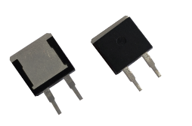

Technical Specifications
Rated Power | Insulation Resistance | Maximum voltage | Output terminal | Insulation Withstand Voltage
35W | ≥10GΩ | 500VDC | Tin-plated copper wire | 2000VAC
Resistance range | Operating Temperature | Optional precision | TC | Installation torque
0.1Ω— | -55℃ | ±0.5% | ±100 | M3 maximum 0.9Nm
1MΩ | +170℃ | ±5% | ppm/℃ | M3 maximum 0.9Nm

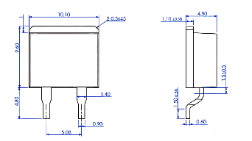

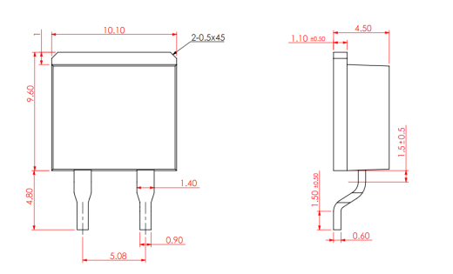

Test Item | Perf Req | Test Standard
Overload | ΔR≤±0.25%R | 1.5P rated power not exceeding 1.5Umax, 5s
Lifetime | ΔR≤±1%R | 2000h at rated power  Steady-State Humidity and Heat
Steady-state humid heat | ΔR≤±0.25%R | MIL-Std-202,Method 103, Condition D
Thermal shock | ΔR≤±0.3%R | -65 to 155°C, 5 cycles
High-frequency vibration | ΔR≤±0.2%R | MIL-Std-202, Method 204, Condition D
Lead strength | ΔR≤±0.2%R | MIL-Std-202, Method 211, Condition A
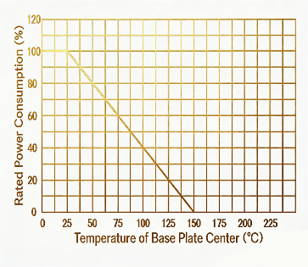
Performance

